04/24/2020
Effective Permissions Sample Application Update!
Hi Folks,
My name is Jeffrey Fishman. I'm a software engineer with the Vault team, and I'm hoping to bring along some goodies you'll find interesting! I'll include a photo of myself below:

The Effective Permissions sample application has been updated to work with the Vault 2021 SDK and client. Since the client now has a native tab to view effective permissions per object, that functionality was removed from the sample application. It'll simply show a permissions matrix users have for each Vault folder, depending on how you've configured the sample application settings.
For those who haven't tried this sample app yet, it calculates which permissions a user will ultimately have for viewing and manipulating a folder in Vault. You can configure the folder depth you wish to be displayed in the matrix, starting from the Vault's root folder ($). You can also configure whether you'd like permissions to be displayed for users who don't have access to the current vault but may be available on the Vault Server, or users who have been disabled on the Vault. The last settings available are folder exclusions and inclusions. The blacklist takes higher precedence over the inclusion, and the inclusion allows you to add folders to the results that may be out of the configured folder depth's scope.
As a quick side note -- you'll want to add in a key to sign the sample code if you wish to compile it. Visual Studio allows you to do this right inside of the IDE by right-clicking on the assembly, selecting 'Properties', and then moving to the 'Signing' section on the left of the assembly properties window.
Outside of Visual Studio, the .NET Framework provides a utility to generate strong-name key files you can find by clicking here.

Screenshots of update:
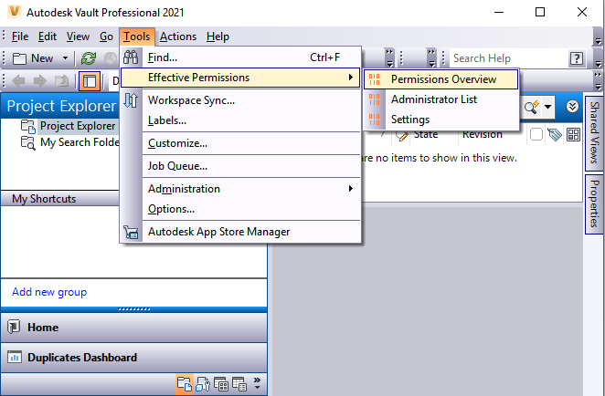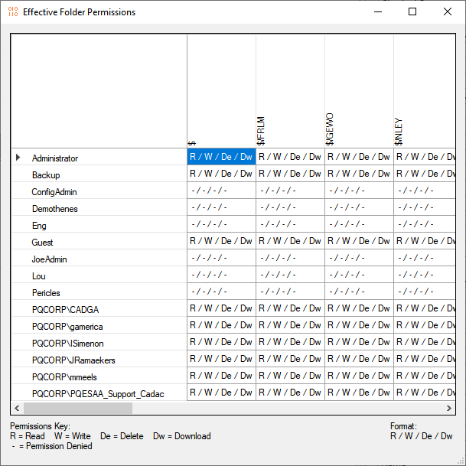

Demo Video:

Requirements:
- Vault 2021 Workgroup or Professional
- Administrative rights on the Vault
Click here to download the application
Click here to download the source code
Click here to go to the previous 2014 version

